Lesson Focus  Timber joints applicable to the attached project |  | Learning Area (Curriculum)  ITD |  | Year Level  TBC |  | Implementation Date 9/10/24
Lesson duration
25 mins
Prior knowledge of learners (What do they already know about this concept/topic/skill?)
Have a foundational awareness of woodworking hand tools
Links to Curriculum (identify relevant Strands and Content Descriptors – the class teacher may provide these)

Learning objectives (Declarative - knowledge) |  |  | Learning objectives (Procedural – skills)
At the end of this lesson, the learners will know how to prepare the timber for the project and commence marking out |  |  | At the end of this lesson, the learners will have been able to prepare for the start of project construction
Key Resources
- Project plans
- timber stock
- pencil, ruler, marking gauge, square, tenon saw

1. Lesson Introduction (introduce the topic and engage the learners)
Timing | What you will do (your teaching steps)
10 min  15 min | Demonstrate how to prepare timber and cut to the required lengths  Send students back to workbenches to mark up pieces and cut all required lengths |  |  |  | - What are your expectations for the lesson?  - What is your hook to engage the learners?  - What are your key prompts?  - What questions will you ask?  - How will you check for understanding/learning?
2. Lesson Body (Teaching the content through specific strategies)
Timing | What you will do (your teaching steps)
10 min  15 min | Demonstrate how to commence marking up the first set of timber pieces ready for removing the dado housing  Send students back to workbenches to attempt the timber joint themselves |  |  |  | - What strategies are you using to teach the content?  - What are your key prompts?  - What questions will you ask?  - How will you check for understanding/learning?

3. Lesson Conclusion (concluding activities, review, check for learning)
Timing | What you will do (your teaching steps)
5 min  10 min | Bring students back to check on how they’ve progressed.  Pack up  Pack up | - How will you summarise the key learnings?  - How do you wrap up the lesson?  - How will you check for understanding/learning?
Lesson Reflection

What worked well or was successful?
Giving context to the outside world and linking it back to a being a scale down version of the example provided.

What did not work well or could be improved?
Give students more time to process information and cognitive directions

I neglected to monitor disengaged learners in real-time and take action to assimilate them back into the task at hand.

Why do I think this occurred?
A lack of familiarity with this group of adolescent minds and subsequent information-processing

What does this mean for your teaching practice and decision-making next time?
I aim to deepen my understanding in this area and become more proficient in knowing my learners.

Project from www.craftsmanspace.com Six-piece interlocking puzzle plan Page 1 of 6

Six-piece interlocking puzzle plan

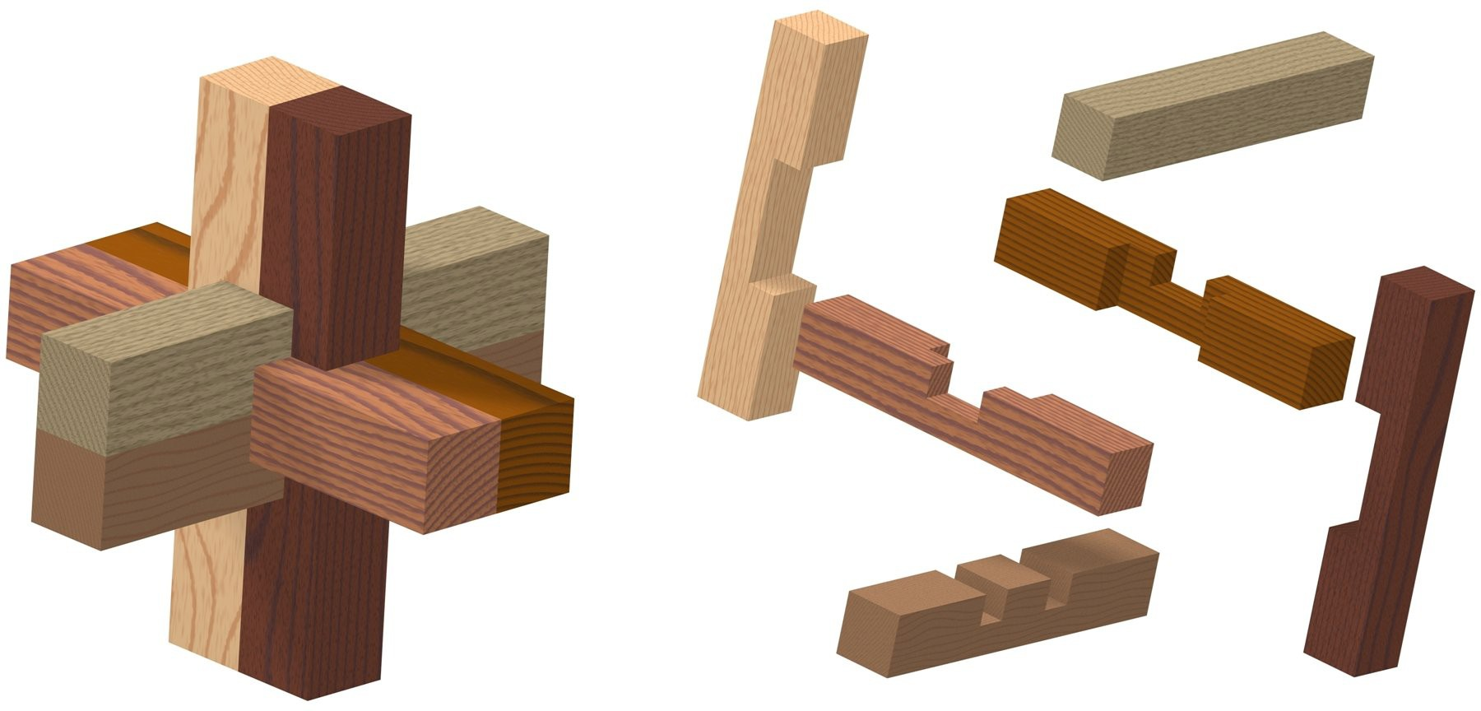

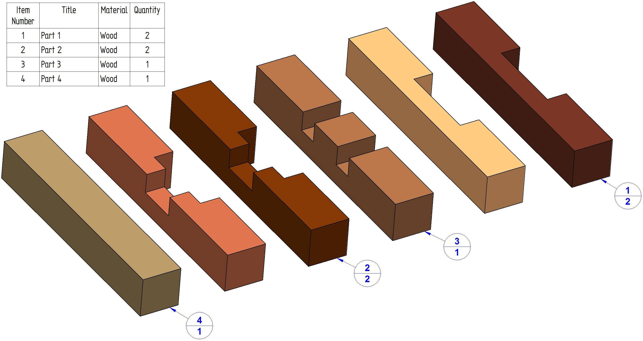
Project from www.craftsmanspace.com Six-piece interlocking puzzle plan Page 2 of 6

Parts List

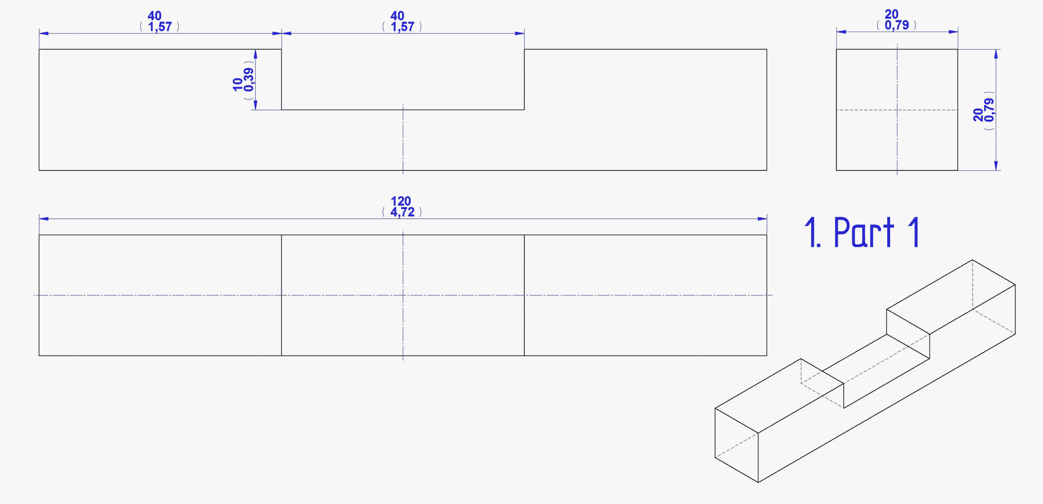

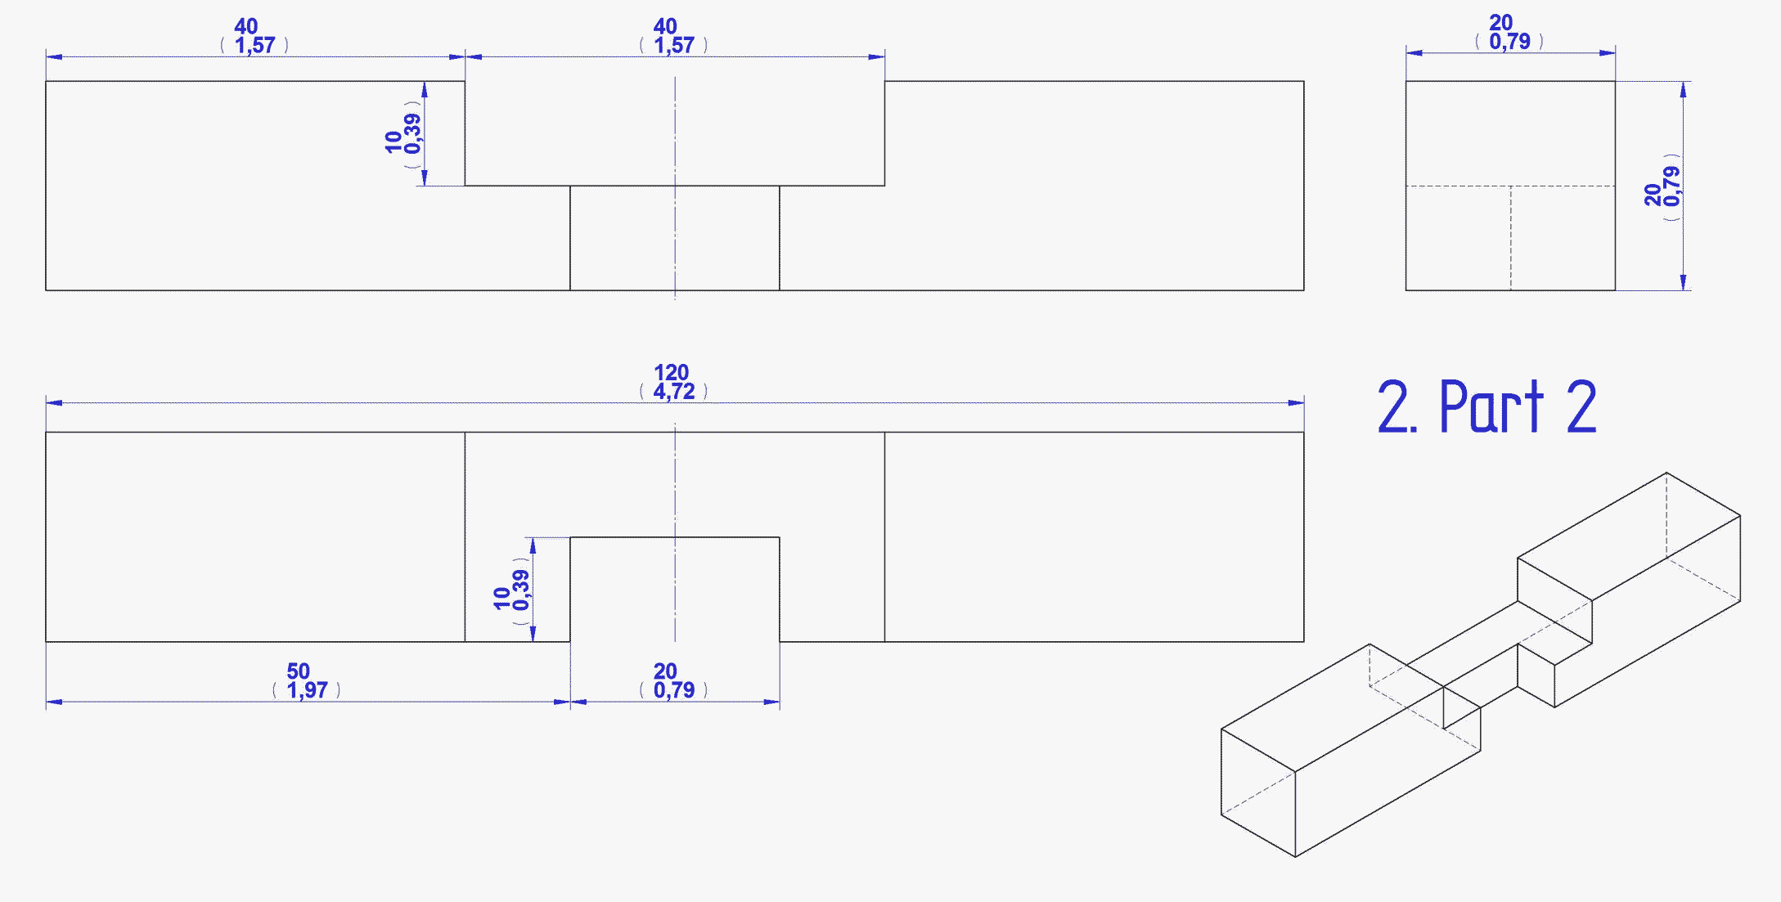

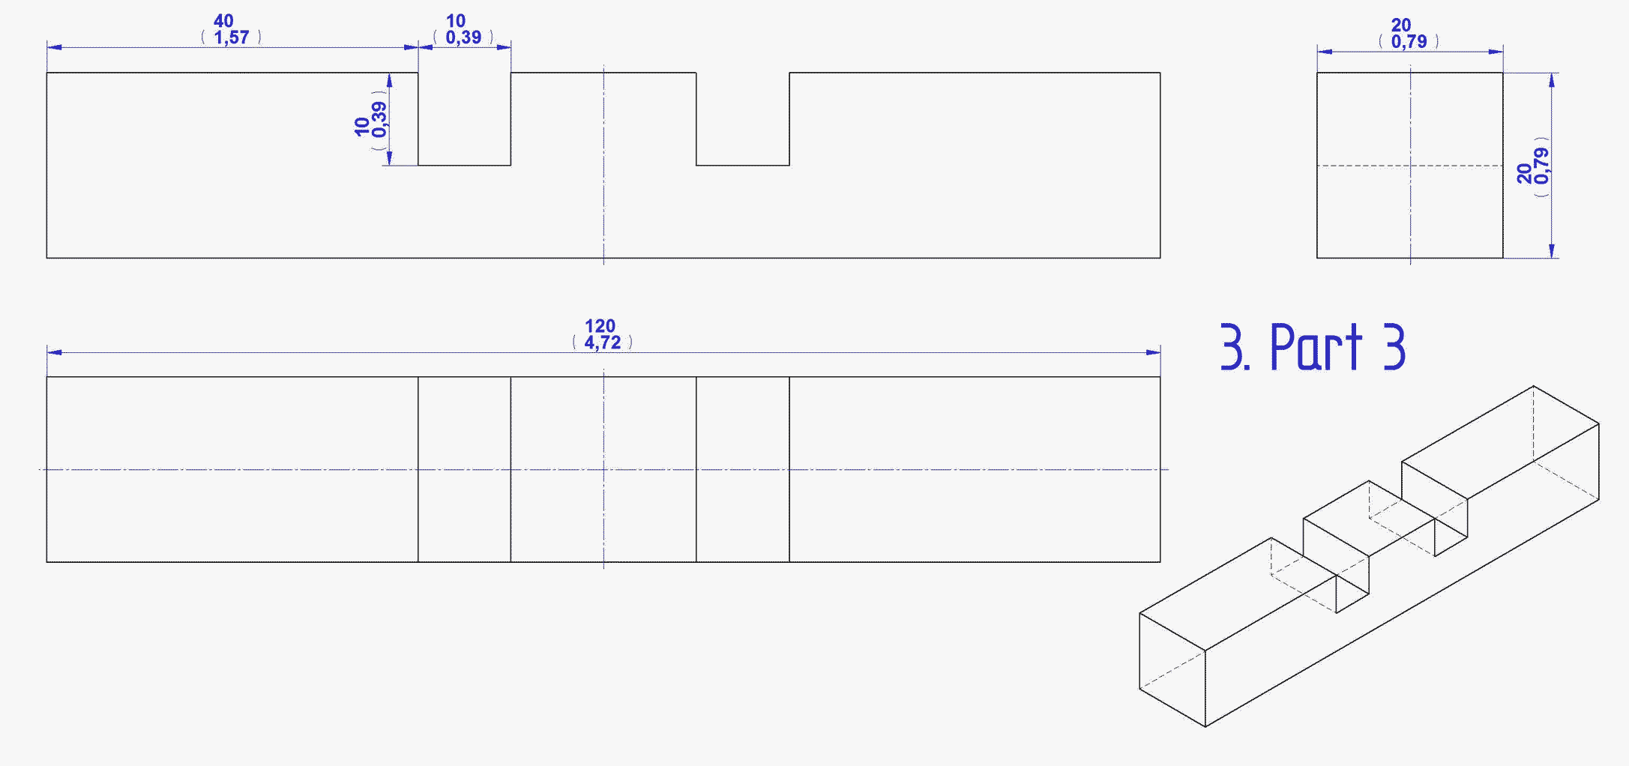

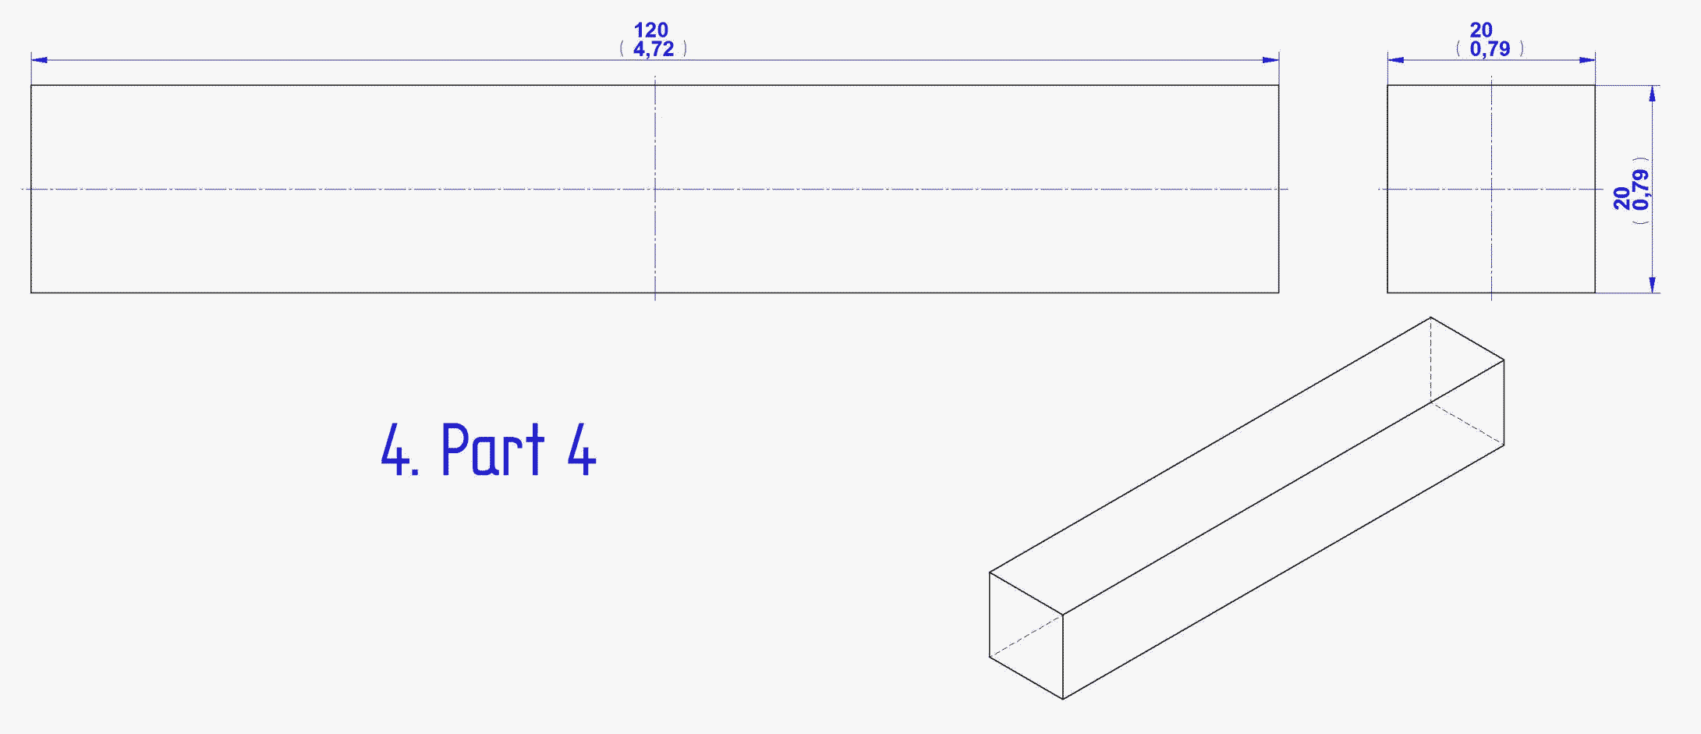

Solution

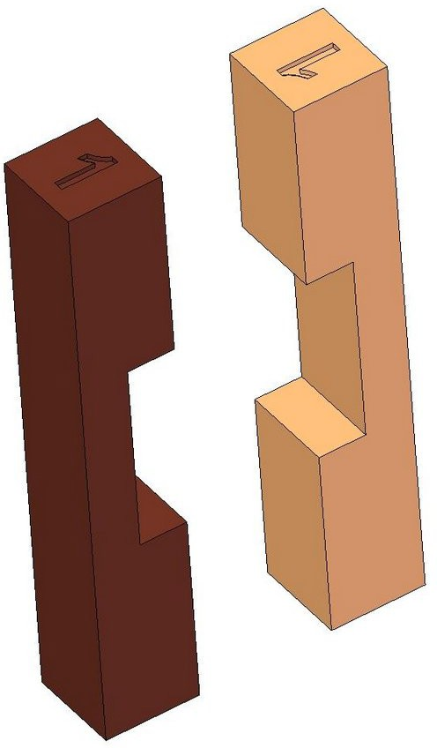
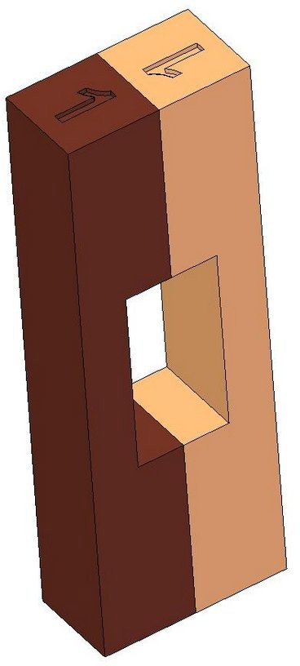
Step 1

Step 2
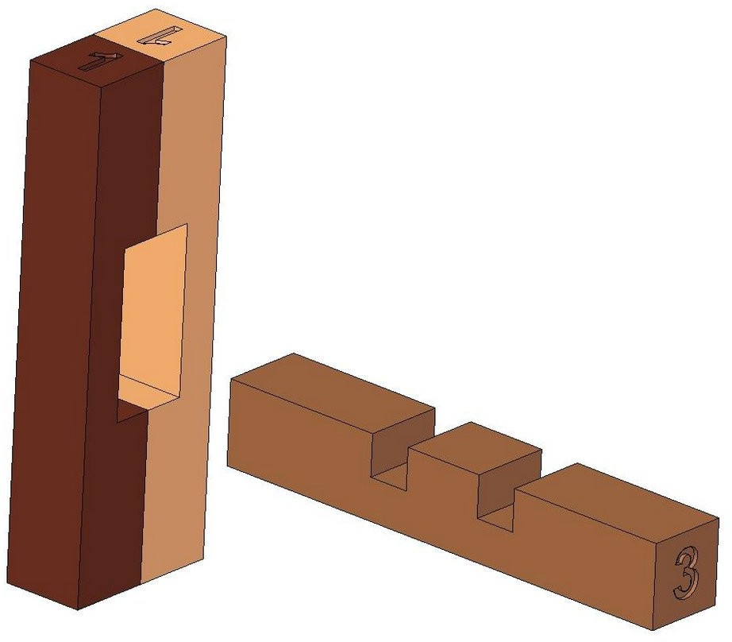
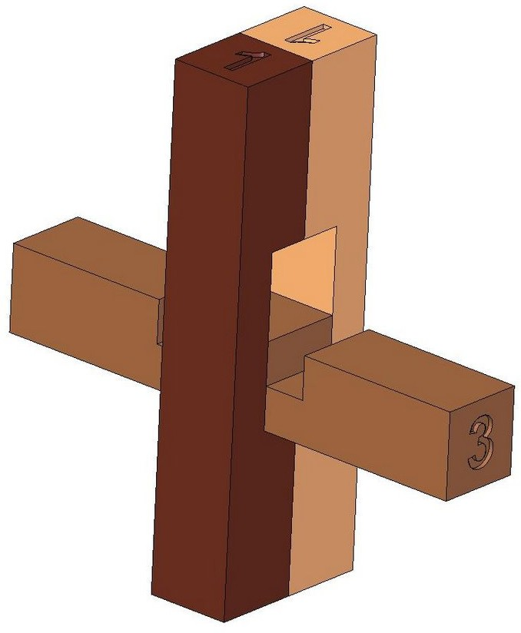

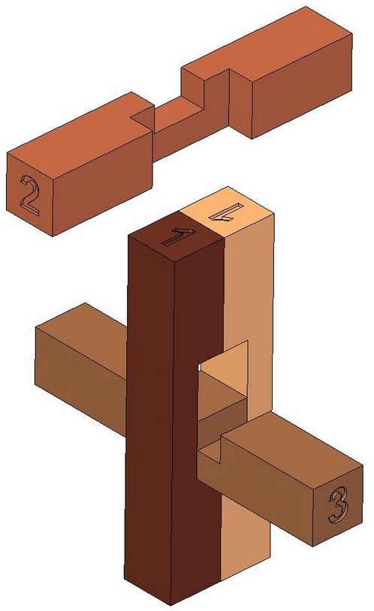
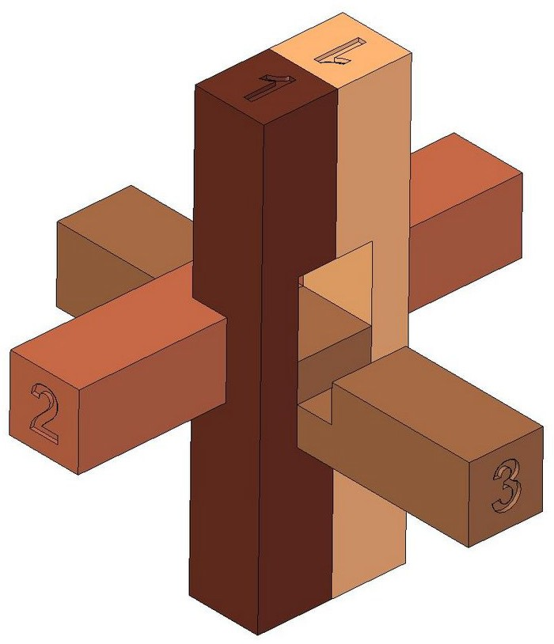
Step 3

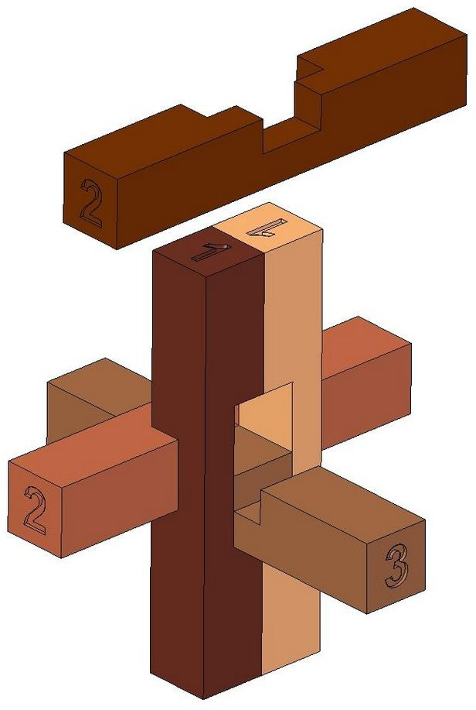
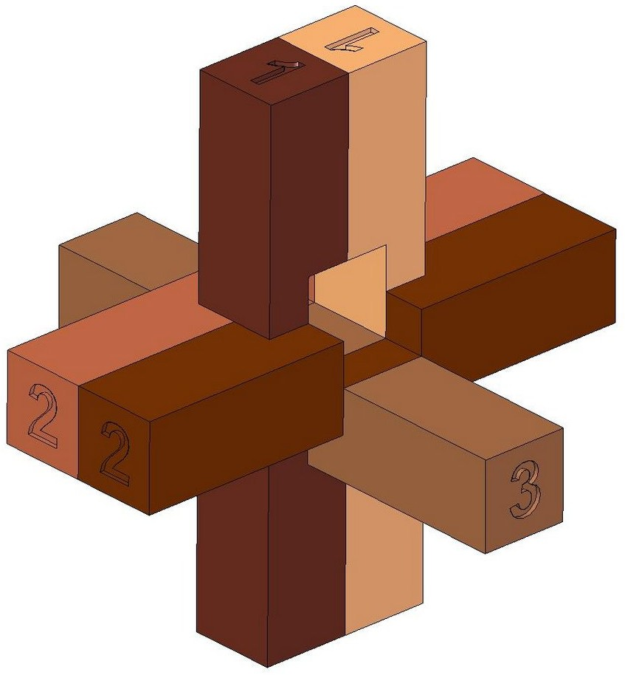
Step 4

Step 5
